Title or Task: | Computer Hardware Worksheet    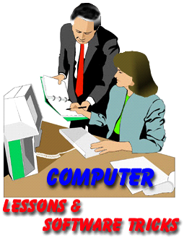

Description:

Files Required
Suitable for Classes: | AIT • Multimedia • Cert II IT • Cert II Bus
Area: | Technology & Enterprise
Teacher: | Mr Peter Faulks

Timeline

Date Due:
Task Brief: | In class lesson

Outcomes:

Items highlighted in yellow are tasks for you to complete
Items in Blue italics are help tips

These pages are designed to show you how to use software packages; various software updates may have taken place so some pages will not apply to versions other than those listed here. In some cases data files may be required.

Teachers See also: Cert II IT 01_02 Computer Hardware Quiz

Complete this sheet and show to Mr Faulks

Save as: yourname_124_Quiz.doc
Computer Basics Quiz, answer as many as you can.

Computer Basics Quiz Start

The Four Basic Functions of a Computer
1. Input -- Input devices enable us to get information into a computer. Some
examples include (name at least 2)
Answer.
2. Storage -- There are two types of storage: temporary and long-term. RAM, what does RAM stand for?
Answer

RAM is temporary, meaning it stores information as you use it, but it is being constantly erased and rewritten as you open and close files.

Long-term storage holds information for as long as you want it.
List at least 2 long term storage devices
Answer :

3. Processor -- A microprocessor controls the computers’ functions. It can be as small as a dime or larger such as 1-2" , but contains millions of transistors that perform millions of instructions per second. The microprocessor performs these instructions using a three-step process: F , D & E what do theses leters stand for?

Answer :

4. Output -- Information that has been processed is communicated back to the user in the form of words, sounds or pictures, and sometimes output is just written back to a storage devicebut often it is delivered through
output devices name at least 2 output devoces

Answer :

Q1. Label the main parts of a computer and various hardware components
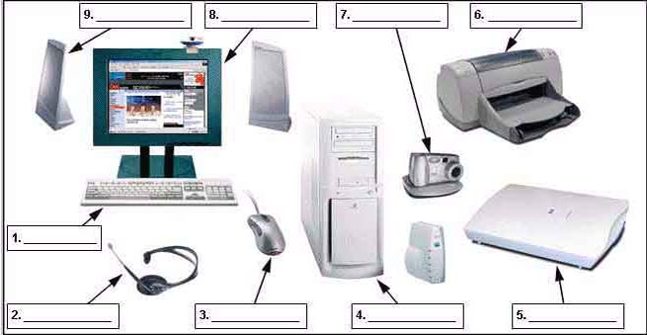

Label these computer parts 10 What is this?
1
2
3
4
5
6
7
8
9

Q2. List the main types of computers
Answer:

Q3. List and describe each function of a computer
Answer:

Q4. List and describe some storage devices and their basic categories
Answer:

Q5. How do you access system information from the Start Menu?
Answer:
Q6. What is a Jump Thumb or USB Drive?
Answer:
Q7. How do you add shortcut icons to the desktop?
Answer:
Q8. How do you add programs into the start menu?
Answer:
Q9. How do you find out the size of a folder – how many megabytes it
Answer:

Q10. How do you rename a file or folder?
Answer:
Q11. If you delete a file how can you restore it?
Answer:
Q12. How do you adjust the date and time on the desktop?
Answer:
Q13. What are 3 different ways you can access a file or folder?
Answer:
Q14. In Windows Explorer what are 3 ways to select multiple files?
Answer:
Q15. How do you add photos and slide shows to your desktop or screensaver?
Answer:
Q16. How do you change the way the files are displayed in the open dialogue box?
Answer:
Q17. How do you check on the progress of a print job?
Answer:
Q18. How do you change the default printer?
Answer:

Q19. Name the parts of the desktop in the picture below and the function of each. Draw a text box over the graphic for each area.

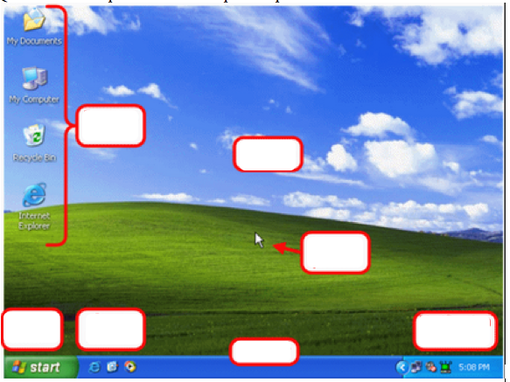

Functions

I.e. Desktop

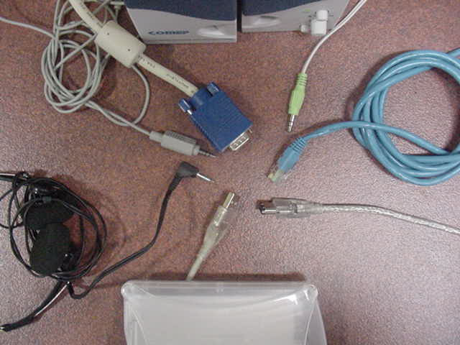
Draw arrows to identify each cable note there may be more than listed

Headphone MiniDIN Video Ethernet (network) Firewire USB Mini Speaker

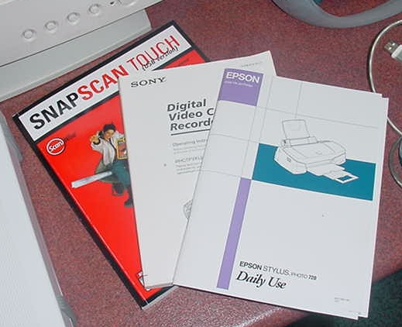
Answer:

Manuals give advice about ….
Identify arrows from labeled text boxes to each hardware component

i.e.

Stereo Speakers

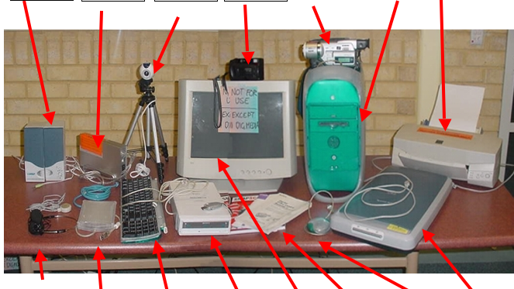

Label the common hardware used in the workplace.

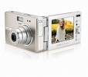 | 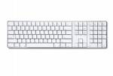 | 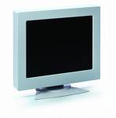 | 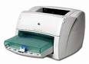
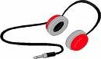 | 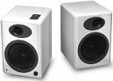 | 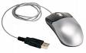 | 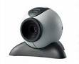
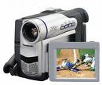 | 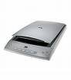 | 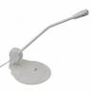 | 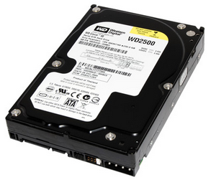
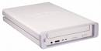 | 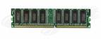 | 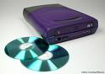 | 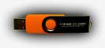

END of QUIZ

